NYSE Sqoop Project

1. Create Table nasdaq_daily_prices table in mySQL. Import the tsv files using the command below with a \t delimiter.

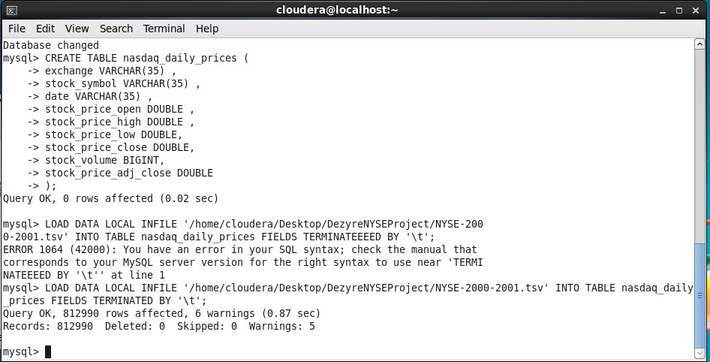

1. Read the first 10 rows to ensure the rows are loaded accordingly.

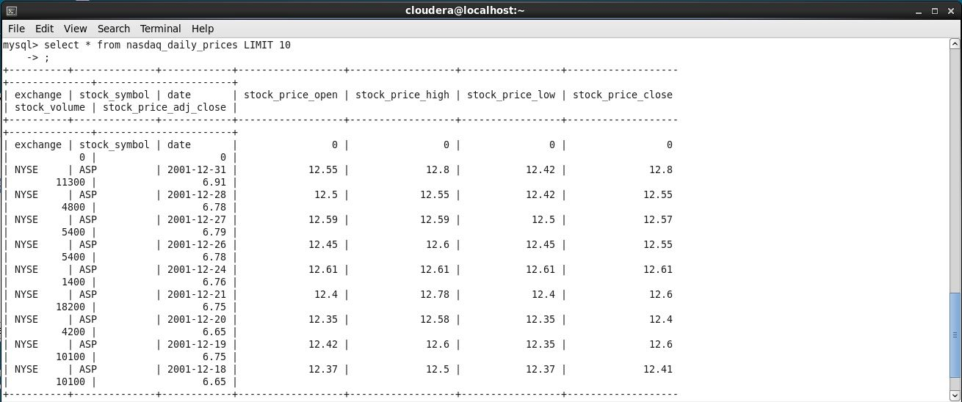

1. Import the data from sql to hive using the sqoop import command, using the jdbc driver and using the –hive-import switch to import the data into a hive table directly.

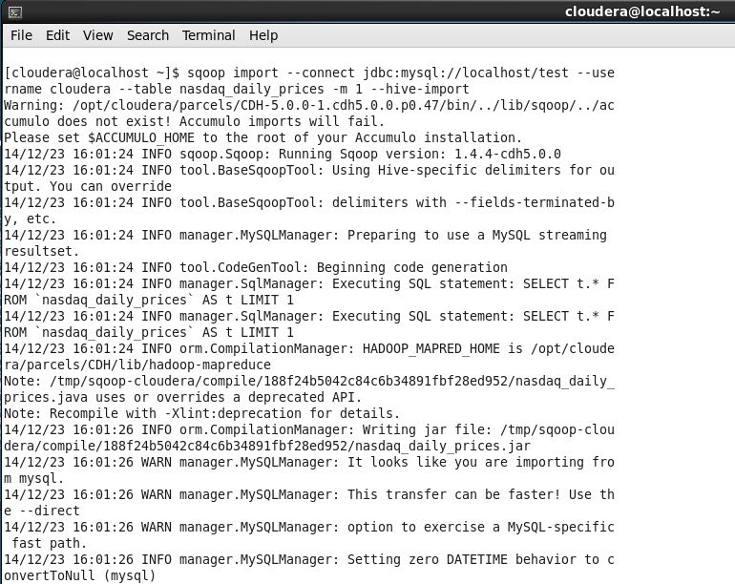

1. Logs for sqoop import. 1 map job created to import the data.

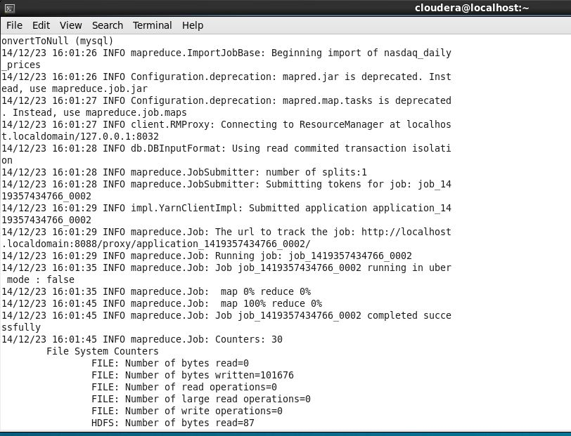

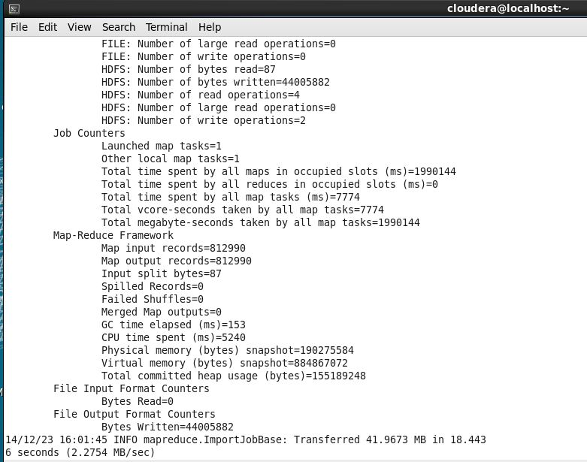

1. Logs from the sqoop import job creating the hive table, file stored in /user/hive/warehouse and the resulting map-red job details from browser

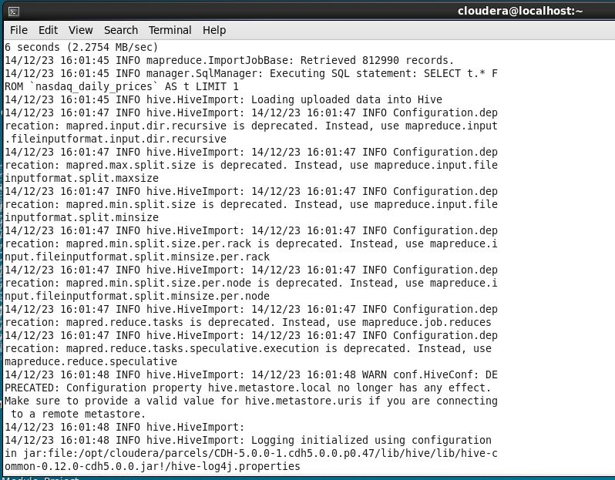

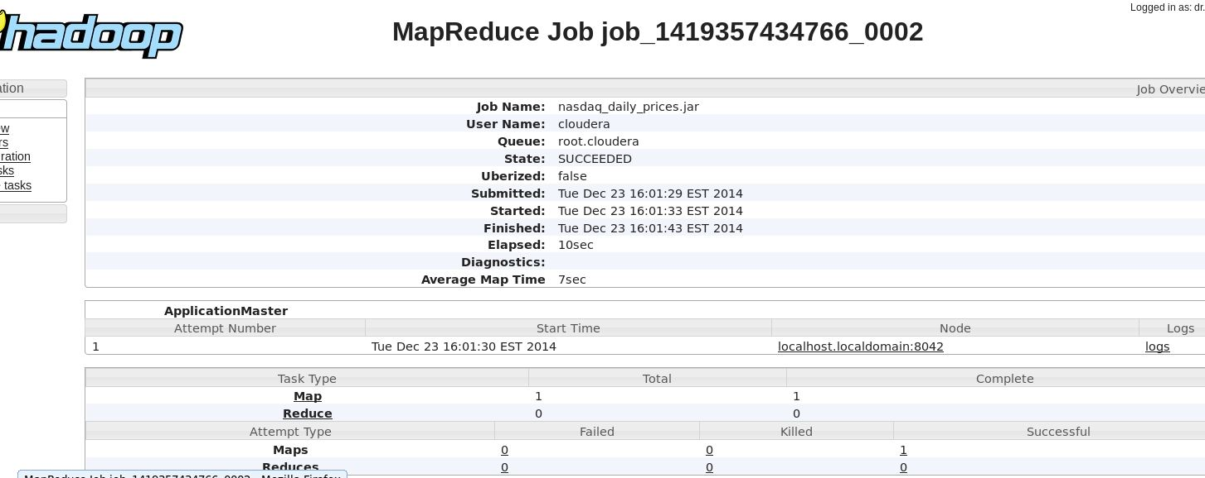

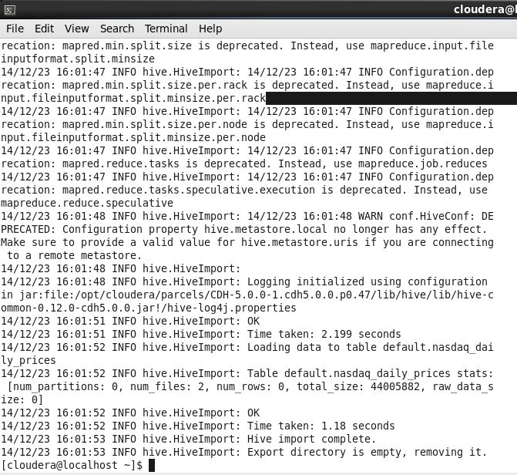

1. Select the top 10 rows from the table to ensure the data is imported successfully.

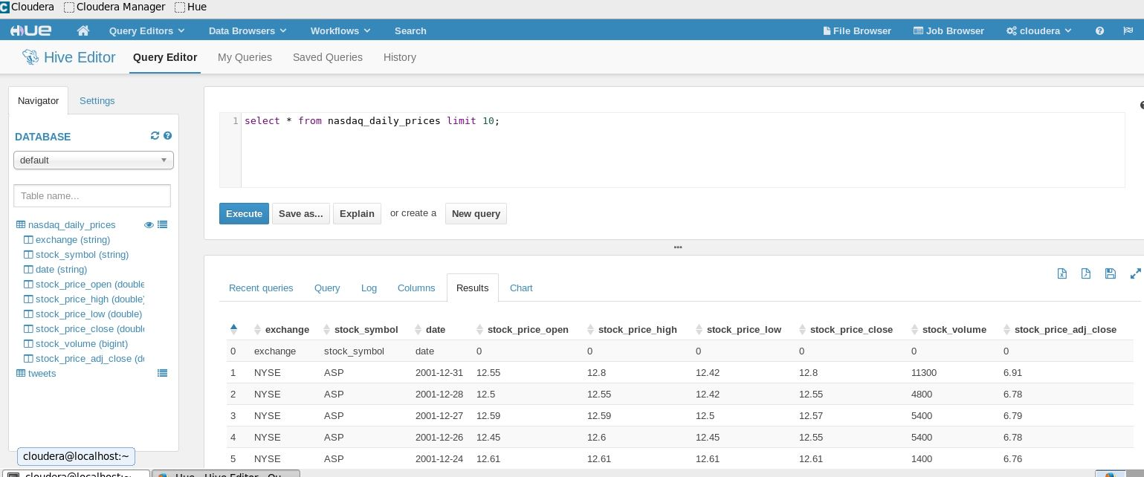

1. Select the stock volume sum for each stock_symbol, we will use this query later to create the table that we will use to export the data back into mysql.

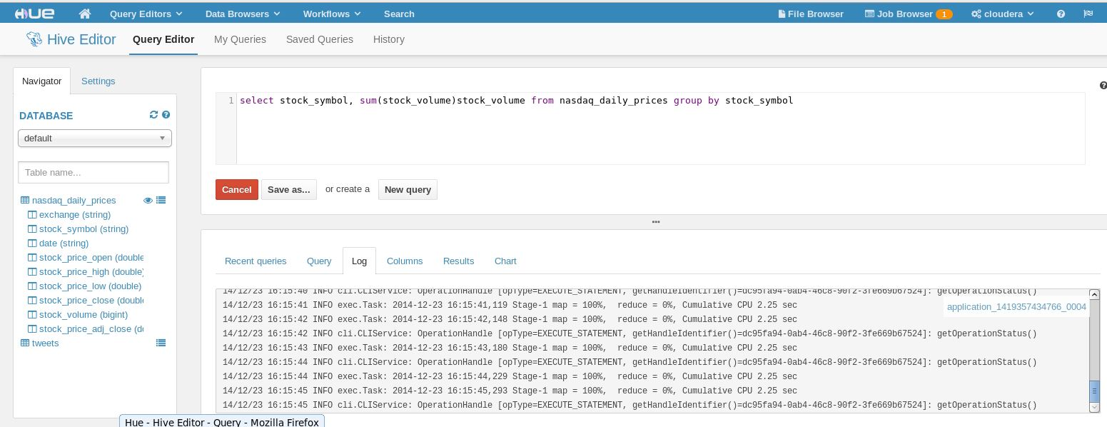

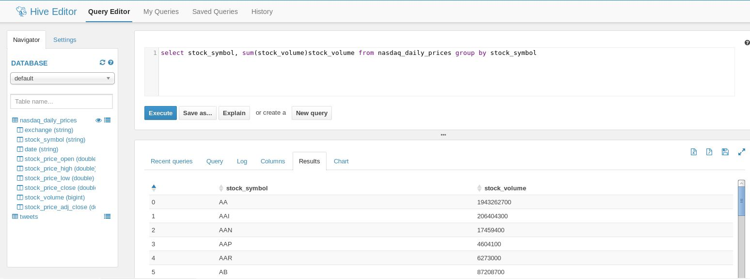

1. Stock_volume table created with a \t row format to store the intermediate sql query data.

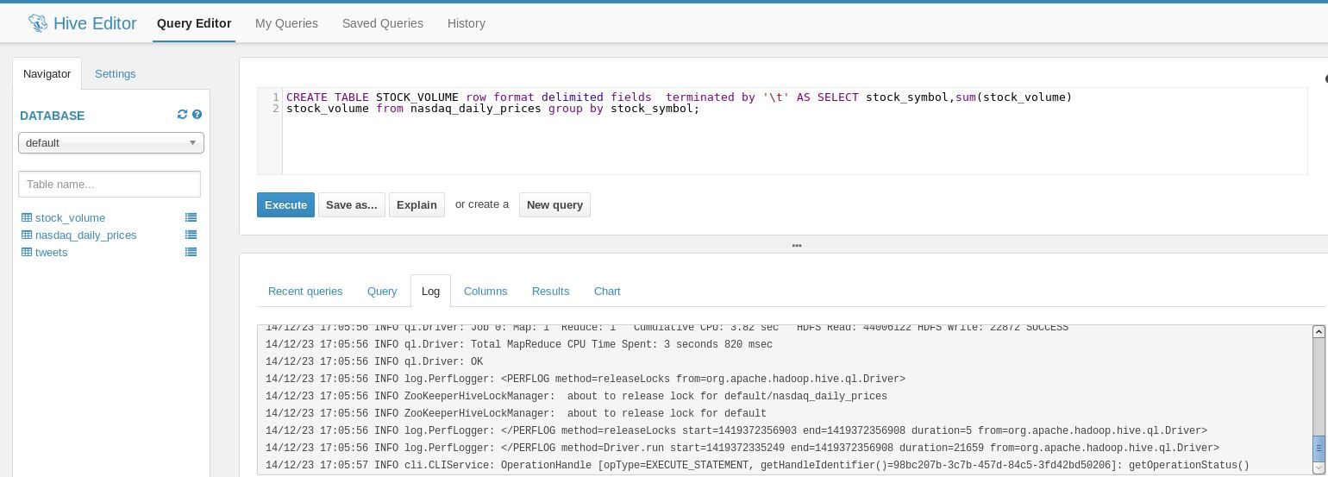

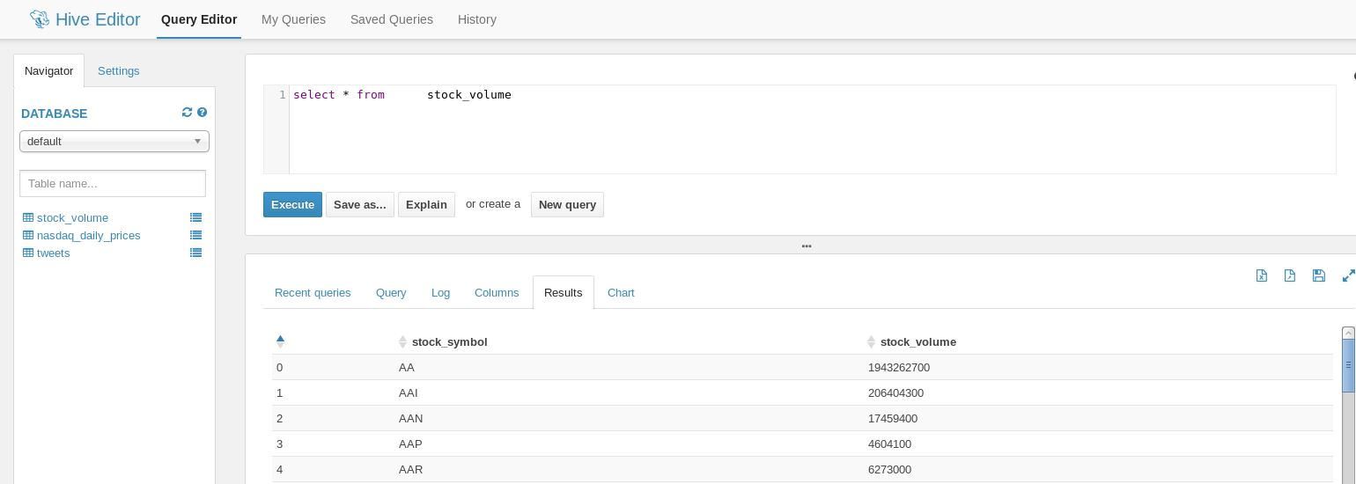

1. Sqoop export command to export the data into a mysql table stock_volume using the stock_volume file with /t terminated.

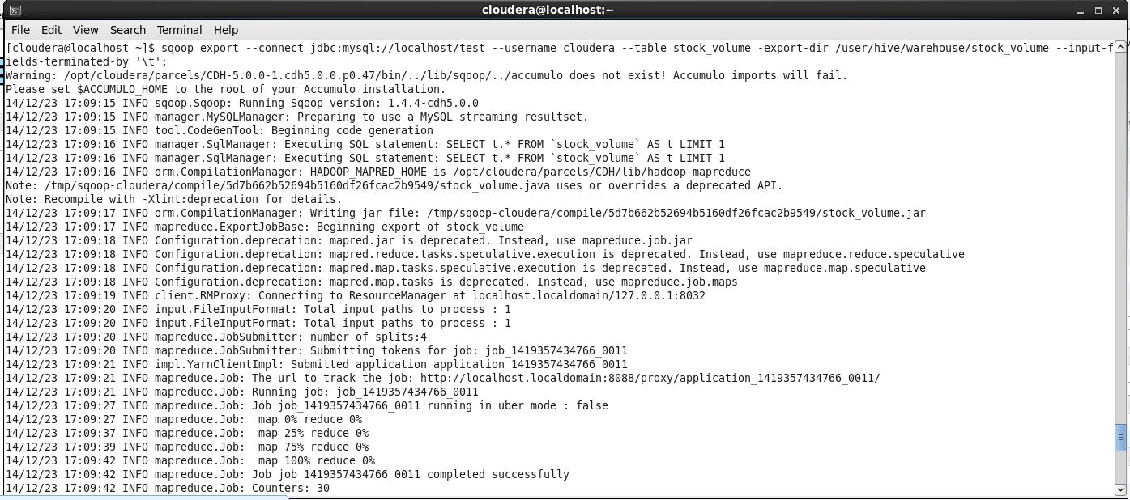

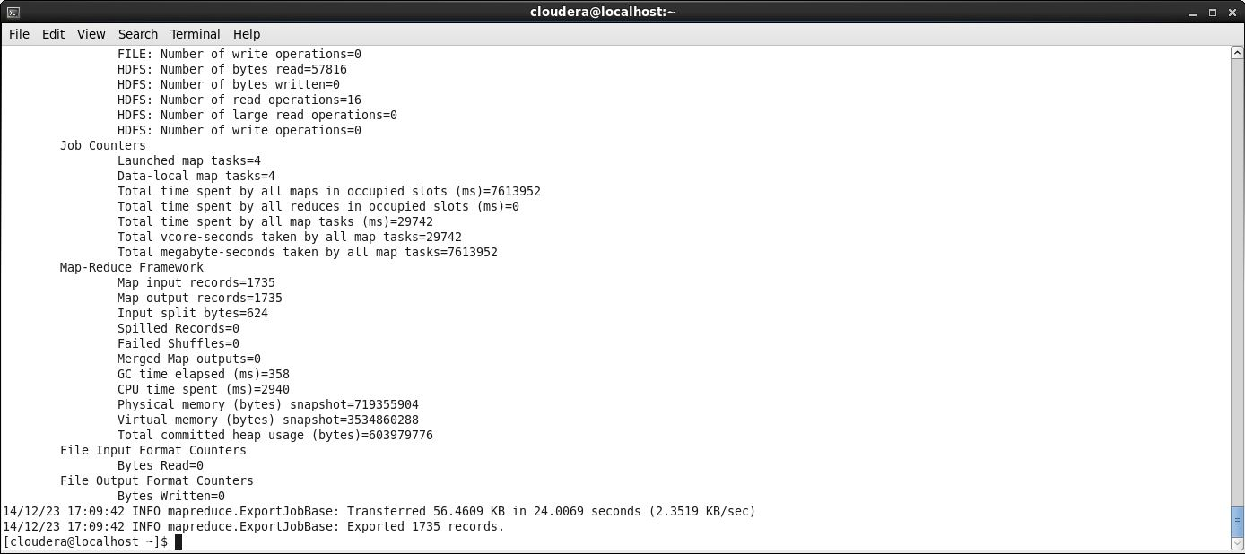

1. After the data in imported to sqoop, one can use this data for reporting, below find the details of the new data and also the number of items match when data is imported from hive to mysql, thereby no data loss.

